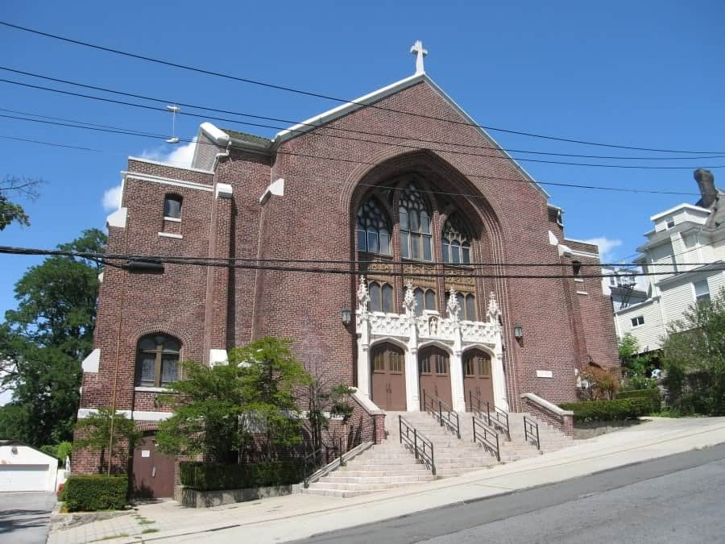

MINIMUM CAPACITY :-

The Minumum intake capacity

of students is between 300-620

children

LIBRARY :-

The Libarary is Available.

CANTEEN:-

The Canteen Facility is Available.

BOARDING :-

No availablility of boarding.

SPORTS :-

There are different categories

sports available.

Girls Volleyball

Boys Volleyball

Football

|  |  |  |
| --- | --- | --- |
| CHARTER SCHOOL OF EDUCATIONAL EXCELLENCE  YONKERS - SCHOOL |  |  |
|  |  |  |
| School Detail :- The Charter School of Educational Excellence's mission is to develop students who are critical thinkers, motivated leaders, and lifelong learners. We are committed to a strong partnership with our teachers, parents, community and alumni. |  |